MMAN2130 – Design and Manufacture
Engineering Standards & Engineering Drawings Test
Date: 09/10/2020
zID: ____________

Part A: Short Answer (30 marks)
Q1. As a graduate engineer with a few years of industry experience, you have been asked to mentor an undergraduate student that is doing industrial training at your company. By chance, this student is currently doing MMAN2130. Remembering how much fun you had in this course, you immediately get them working on creating an engineering drawing for an automated bean bag filling machine. However, the drawing that they give you has lots of “chain dimensioning”.
- What are chain dimensions? (1 mark)
Ans:

- What are the real-world issues that chain dimensions could cause? (3 marks)
Ans:

- What must be done to correct this issue? Provide some helpful tips to your new mentee. (3 marks)
Ans:

Q2. One of your closest friends has decided to enter into the lucrative bean bag market and start up his own company, Beanzgineered™. You, being a great friend, remind him that any product he creates must meet a mandatory bean bag safety standard. After years of design work, he returns to you for advice on how to prove compliance to this requirement in the standard.
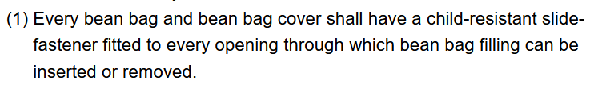
He reveals that his current plan is to provide detailed engineering drawings to prove compliance. What do you think of his plan? (3 marks)
Ans:

Q3. Your friend has recently bought a DMC DeLorean and she has been steadily customising it. Her plan is to one day attempt the Australian land speed record of 802.6 km/h with a road legal vehicle. Her attention has now turned to the wheel guards (see Figure 1) which she is concerned is creating too much drag which will slow her down. She is thinking about removing them or possibly modifying them but isn’t sure if this would cause issues with compliance. She has asked for your assistance in interpreting the following standard and making a decision.
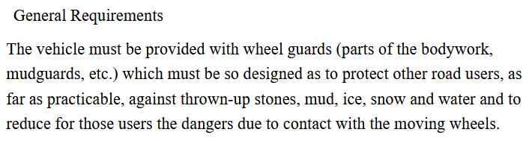
- Do you think this is a well written standard? (2 marks)
Ans:

- If you have concerns with this standard, explain what you think the issue is? Give an example of how it may cause a problem. (4 marks)
Ans:

- In your opinion, will your friend be compliant if she proceeds as planned? Why? (2 marks)
Ans:

Q4. One of your brilliant engineering friends has an amazing idea that they want to use to create a start up to make all the money. However, they are frustrated because they need to comply with various Australian Standards. They feel such stringent rules stifle innovation and make it difficult to be truly competitive. You couldn’t disagree more! What are the reasons you give to convince your friend to the importance and/or benefits of complying with various Australian Standards? (12 marks)
Ans:

